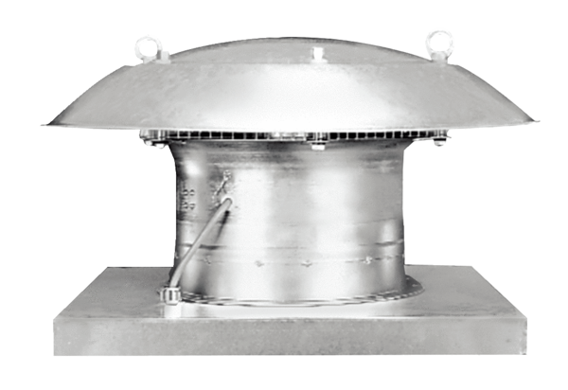Axial roof fan EZD 25/2 BPacking unit: 1 pieceRange: C
Article number: 0087.0202Manufacturer: MAICO

