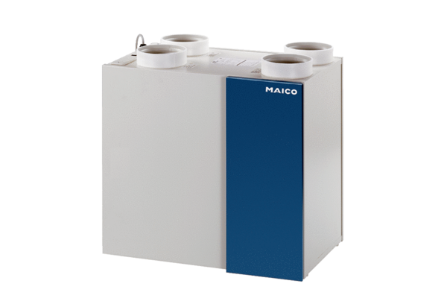Aeronom room air system WRG 300 DCPacking unit: 1 pieceRange: K
Article number: 0082.0048Manufacturer: MAICO

