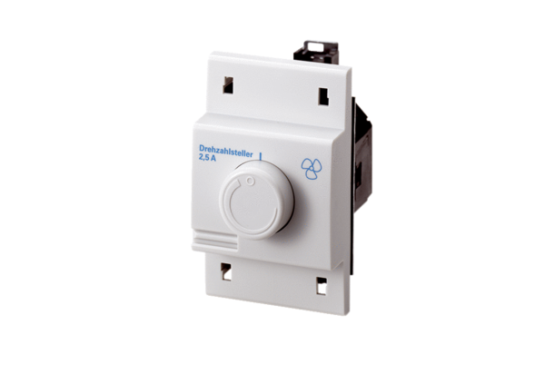Speed controller, distribution board STS 2,5Packing unit: 1 pieceRange: C
Article number: 0157.0255Manufacturer: MAICO

