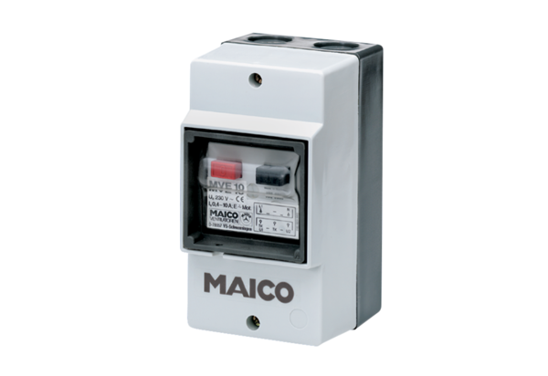Motor protection switch MV 25Packing unit: 1 pieceRange: C
Article number: 0157.0712Manufacturer: MAICO

