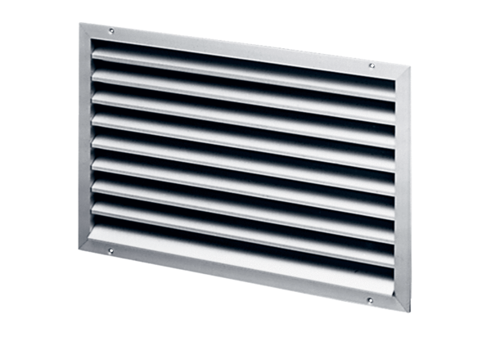External grille LAP 31Packing unit: 1 pieceRange: D
Article number: 0151.0253Manufacturer: MAICO

