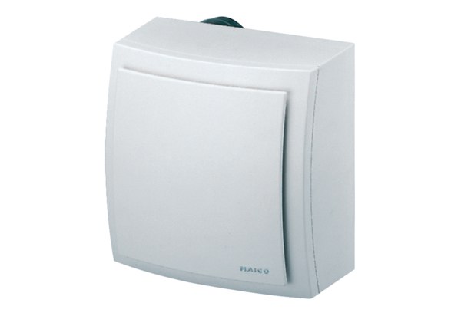Surface-mounted fan ER-AP 100 FPacking unit: 1 pieceRange: B
Article number: 0084.0172Manufacturer: MAICO

