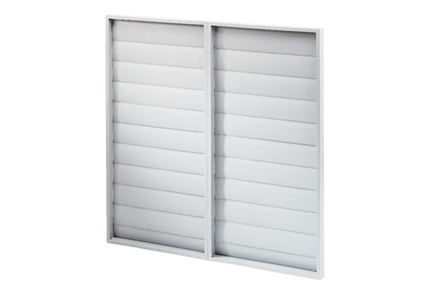Shutter ARP 71Packing unit: 1 pieceRange: C
Article number: 0151.0082Manufacturer: MAICO

