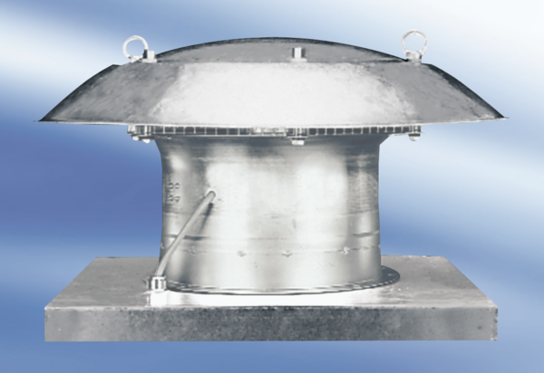Axial roof fan EZD50-6APacking unit: 1 pieceRange:
Article number: 0087.0411Manufacturer: MAICO

