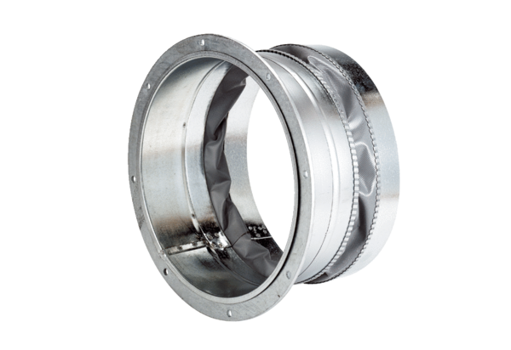Flexible coupling ELA 18Packing unit: 1 pieceRange: C
Article number: 0092.0283Manufacturer: MAICO

