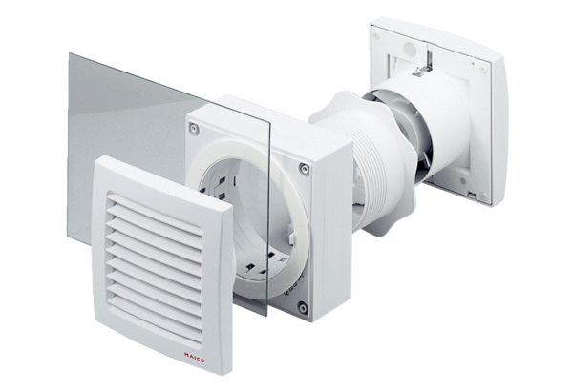Window installation kit FE 100 SGPacking unit: 1 pieceRange: A
Article number: 0093.1023Manufacturer: MAICO

