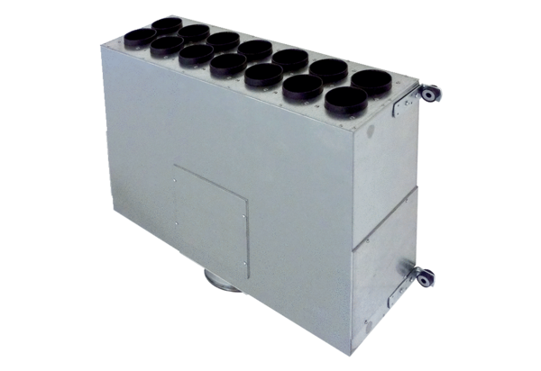Air distributor box made of sheet metal, 14-way MF-BV63-160-14Packing unit: 1 pieceRange: K
Article number: 0018.0526Manufacturer: MAICO

