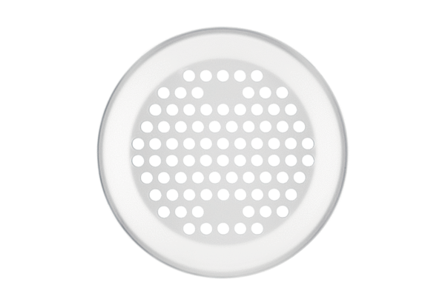Wall/Ceiling grille FFS-WGBWPacking unit: 1 pieceRange: K
Article number: 0055.0894Manufacturer: MAICO

