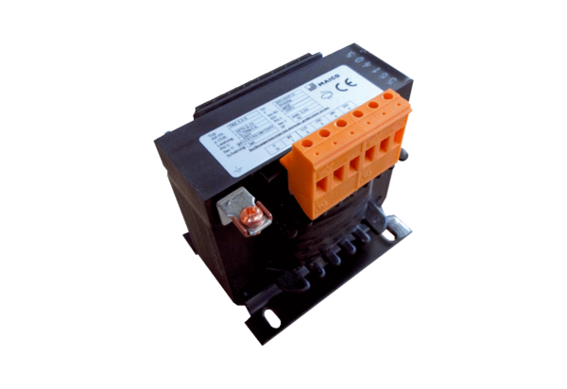5-step transformer, control cabinet TRE 6,5 S-2Packing unit: 1 pieceRange: C
Article number: 0157.0164Manufacturer: MAICO

