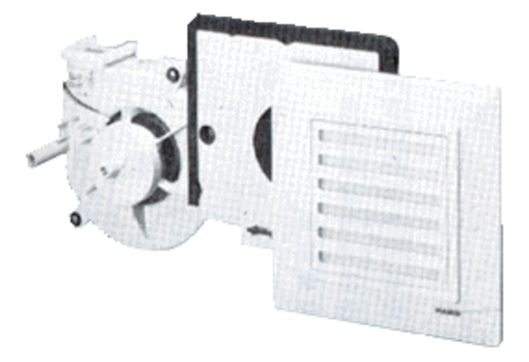Fan insert ER 17/60 GPacking unit: 1 pieceRange:
Article number: 0080.0738Manufacturer: MAICO

