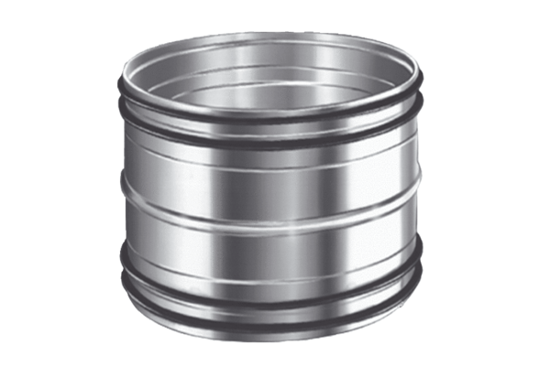Plug connectors for ducts SVR 160Packing unit: 1 pieceRange: K
Article number: 0055.0185Manufacturer: MAICO

