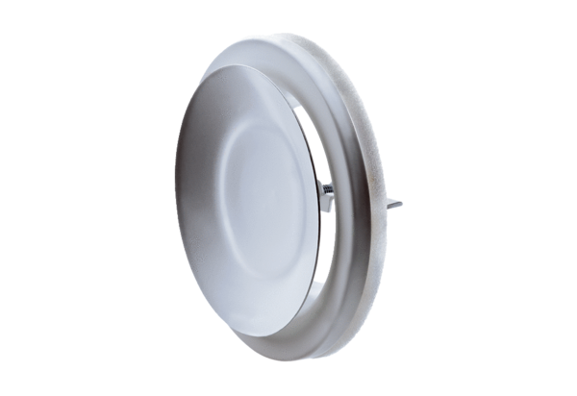Disk valve, metal TFZ 10Packing unit: 1 pieceRange: C
Article number: 0151.0364Manufacturer: MAICO

