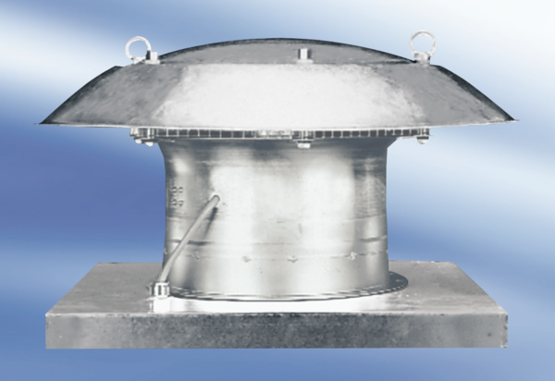Axial roof fan DZD 50/84 APacking unit: 1 pieceRange:
Article number: 0087.0449Manufacturer: MAICO

