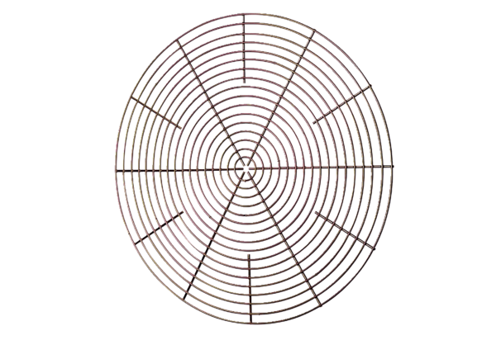Protective grille, metal SG 60Packing unit: 1 pieceRange: C
Article number: 0150.0122Manufacturer: MAICO

