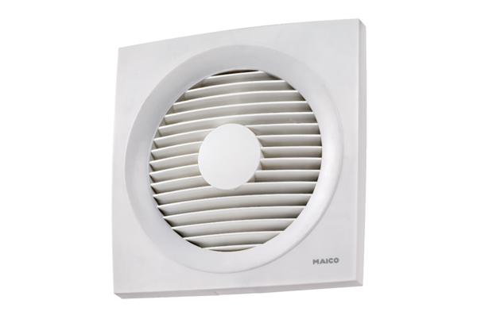Axial wall-mounted fan EN 25Packing unit: 1 pieceRange: C
Article number: 0081.0308Manufacturer: MAICO

