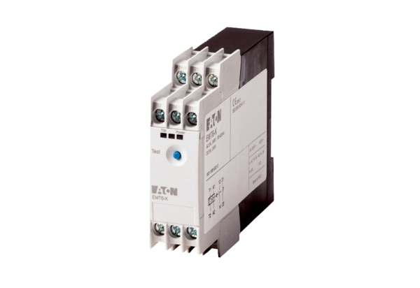Machine protection relay thermistor TMSPacking unit: 1 pieceRange: C
Article number: 0157.0992Manufacturer: MAICO

