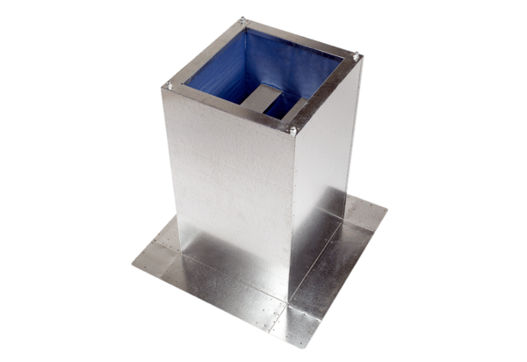Socket sound absorber SD 31Packing unit: 1 pieceRange: C
Article number: 0092.0340Manufacturer: MAICO

