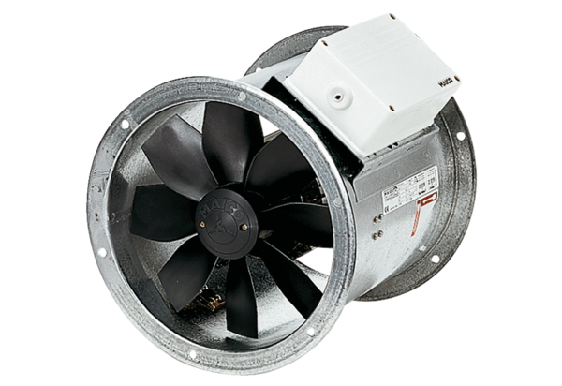Axial duct fan DZR 35/2 BPacking unit: 1 pieceRange: C
Article number: 0086.0060Manufacturer: MAICO

