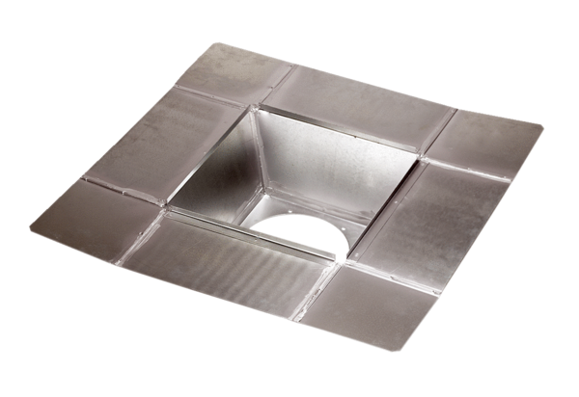Intermediate socket SZ 22Packing unit: 1 pieceRange: C
Article number: 0092.0287Manufacturer: MAICO

