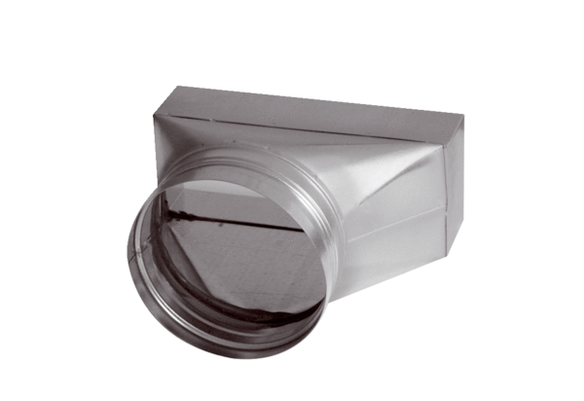Intermediate piece, asymmetric USAN80/100/100Packing unit: 1 pieceRange: K
Article number: 0055.0666Manufacturer: MAICO

