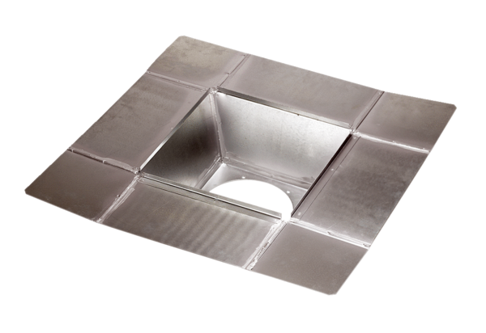Intermediate socket SZ 40Packing unit: 1 pieceRange: C
Article number: 0092.0291Manufacturer: MAICO

