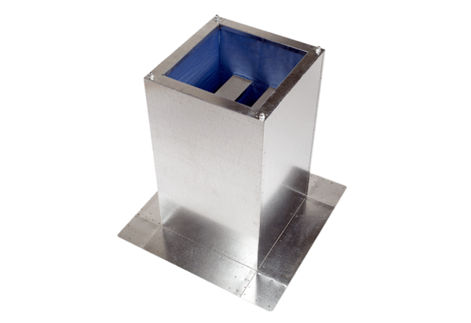Socket sound absorber SD 25Packing unit: 1 pieceRange: C
Article number: 0092.0339Manufacturer: MAICO

