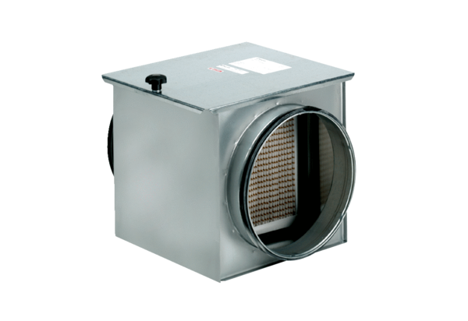Air filter TFE 10-5Packing unit: 1 pieceRange: C
Article number: 0149.0058Manufacturer: MAICO

