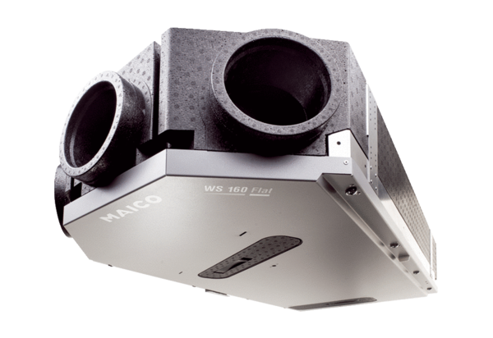Centralised ventilation unit WS 160 Flat KBZETPacking unit: 1 pieceRange: K
Article number: 0095.0094Manufacturer: MAICO

