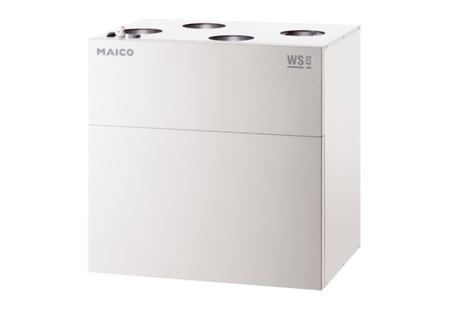Centralised ventilation unit WS 470 ETPacking unit: 1 pieceRange: K
Article number: 0095.0232Manufacturer: MAICO

