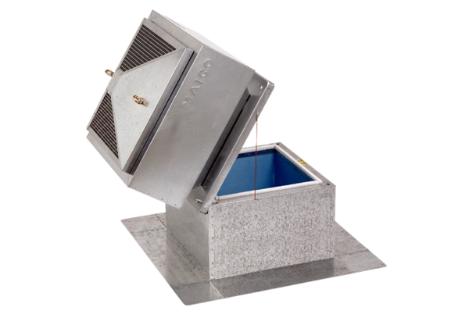Roof socket for flat roofs, tiltable SOK 31Packing unit: 1 pieceRange: C
Article number: 0093.0993Manufacturer: MAICO

