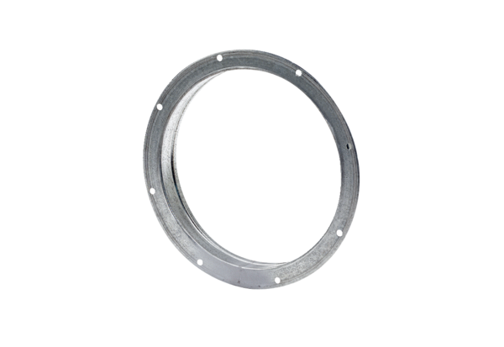Counter socket GS 30Packing unit: 1 pieceRange: C
Article number: 0055.0170Manufacturer: MAICO

