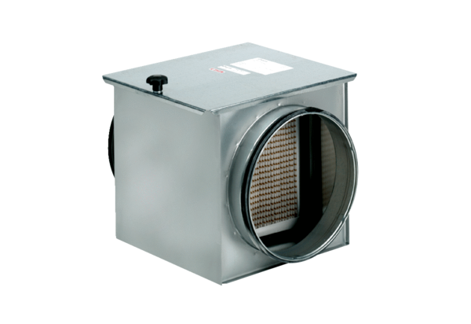Air filter TFE 10-7Packing unit: 1 pieceRange: C
Article number: 0149.0049Manufacturer: MAICO

