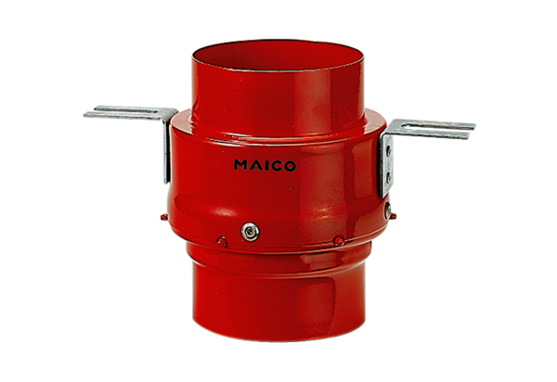Fire protection ceiling barrier TS 18 DN 200Packing unit: 1 pieceRange: B
Article number: 0151.0325Manufacturer: MAICO

