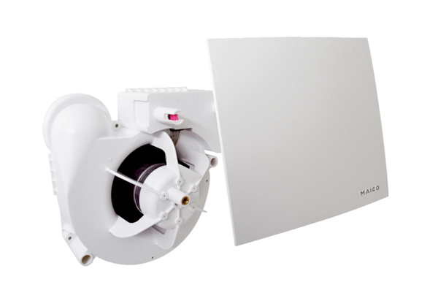Fan insert ER 60 EGPacking unit: 1 pieceRange:
Article number: 0084.0374Manufacturer: MAICO

