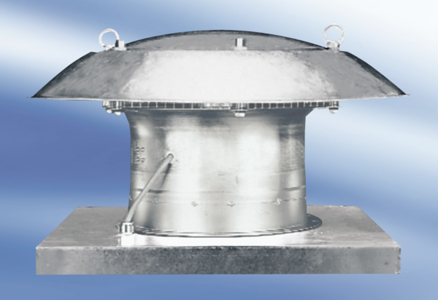Axial roof fan DZD 40/84 APacking unit: 1 pieceRange:
Article number: 0087.0444Manufacturer: MAICO

