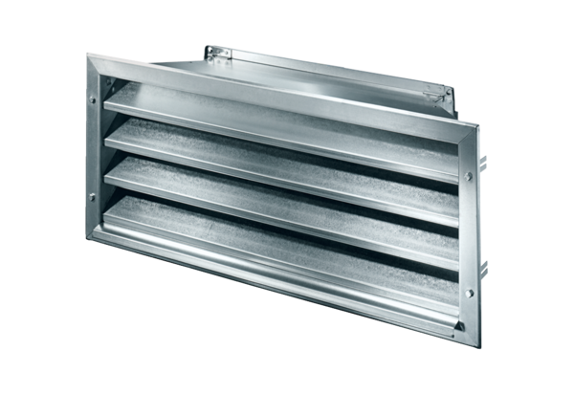External grille LZP-R 35Packing unit: 1 pieceRange: D
Article number: 0151.0385Manufacturer: MAICO

