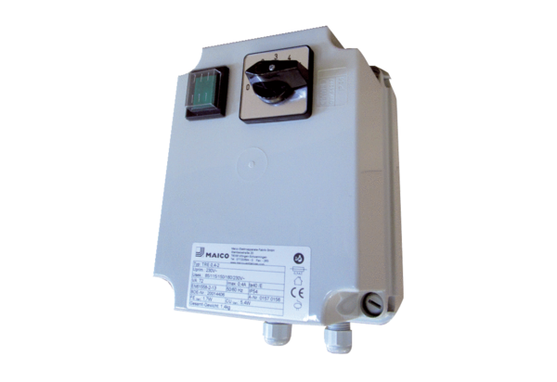5-step transformer TRE 3,3-2Packing unit: 1 pieceRange: C
Article number: 0157.0159Manufacturer: MAICO

