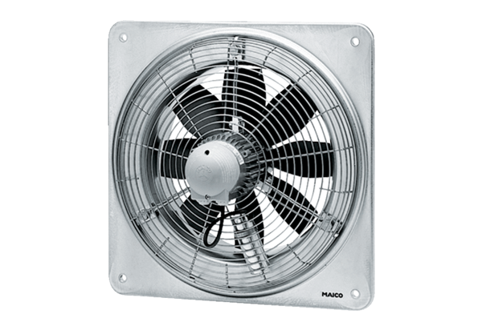Axial wall fan EZQ 40/4 BPacking unit: 1 pieceRange: C
Article number: 0083.0115Manufacturer: MAICO

