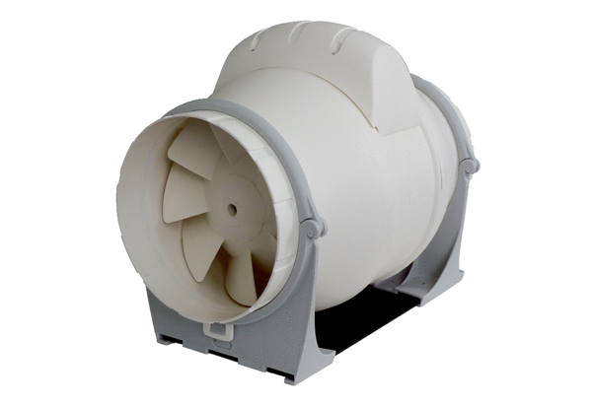Diagonal fan ERK 125Packing unit: 1 pieceRange: C
Article number: 0080.0177Manufacturer: MAICO

