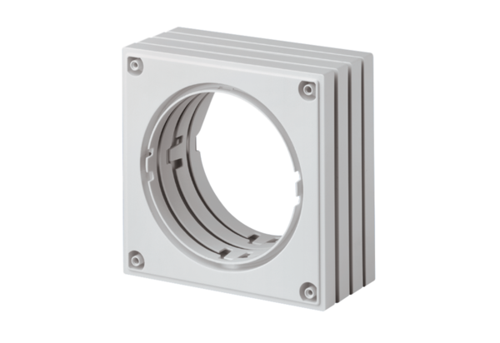Spacer ECA-AHPacking unit: 1 pieceRange: A
Article number: 0092.0486Manufacturer: MAICO

