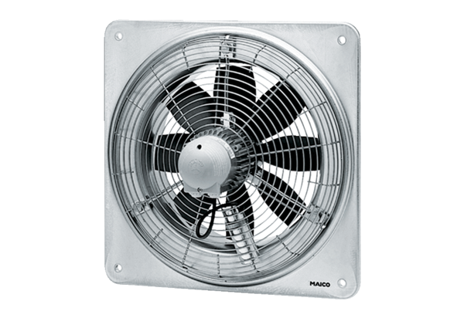Axial wall fan DZQ 30/2 BPacking unit: 1 pieceRange: C
Article number: 0083.0121Manufacturer: MAICO

