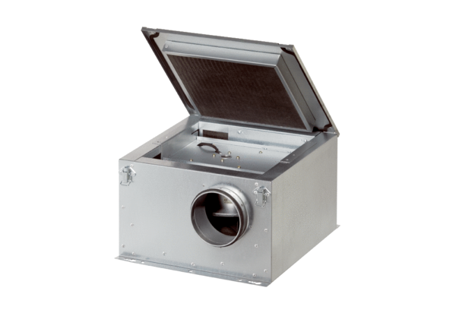Sound-insulated ventilation box ESR 40-2Packing unit: 1 pieceRange: C
Article number: 0080.0616Manufacturer: MAICO

