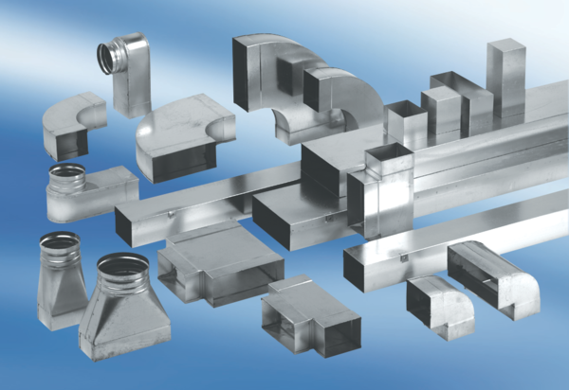40 mm channel sound absorbers with lining and attenuating linging KSDA70/170/700Packing unit: 1 pieceRange: K
Article number: 0092.0463Manufacturer: MAICO

