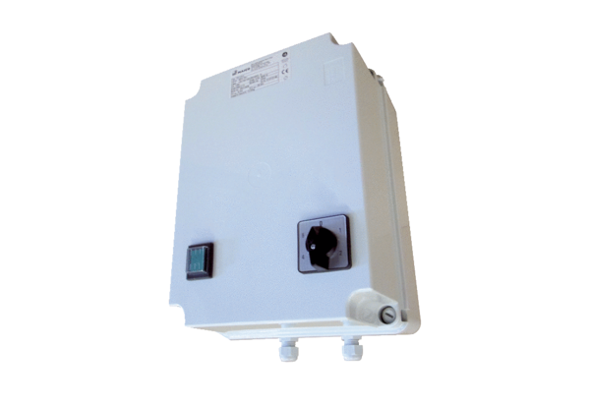5-step transformer TR 2,5-2Packing unit: 1 pieceRange: C
Article number: 0157.0149Manufacturer: MAICO

