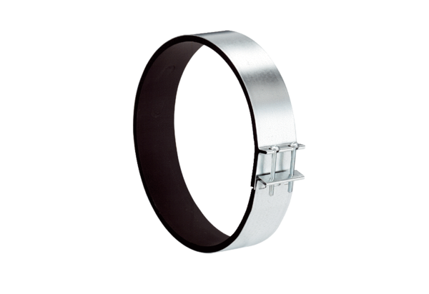Fixing cuff ELR 12Packing unit: 1 pieceRange: C
Article number: 0092.0110Manufacturer: MAICO

