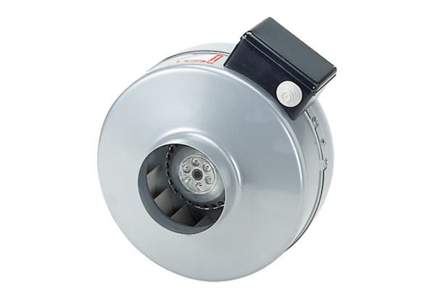Centrifugal duct fan ERR 31/1Packing unit: 1 pieceRange: C
Article number: 0080.0278Manufacturer: MAICO

