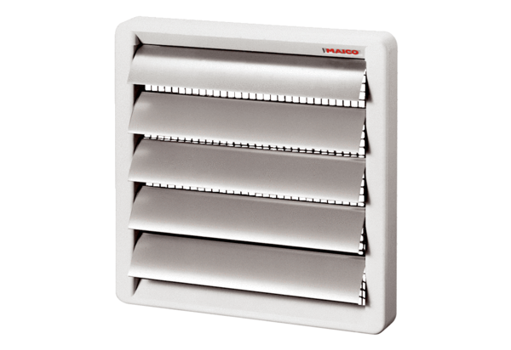Shutter, manual RS 20Packing unit: 1 pieceRange: C
Article number: 0151.0338Manufacturer: MAICO

