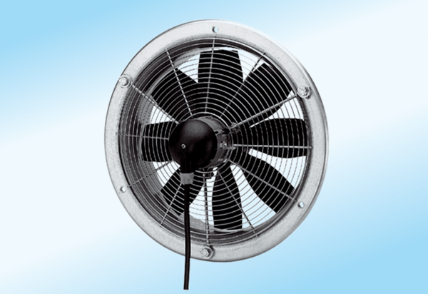Axial wall fan DZS 50/6 A-ExPacking unit: 1 pieceRange: C
Article number: 0094.0113Manufacturer: MAICO

