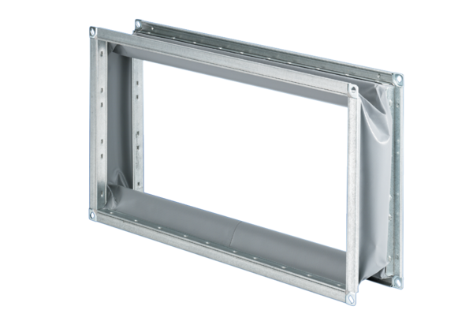Flexible coupling ELP 93Packing unit: 1 pieceRange: D
Article number: 0092.0263Manufacturer: MAICO

