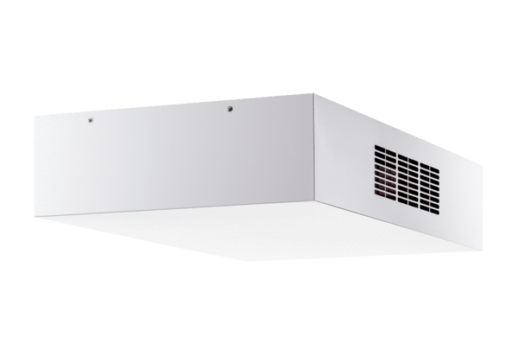Decentralised ventilation unit with heat recovery Trio QD-ARVPacking unit: 1 pieceRange: K
Article number: 0095.0123Manufacturer: MAICO

